Andy Cherney

Week6Meet - 10 pts

Turn in on BBL as soon as complete, but before end of day Sunday following the lecture.

Answer these questions as we progress through the meeting.

1. Declare an array of type int that will hold 50 numbers:

int [] nums = new int [50];

1. Declare an array of type String that will hold the inner planets:

String [] planets = {"Mercury", "Venus", "Earth", "Mars", "Jupiter", "Saturn", "Uranus", "Neptune"};

1. Print out Earth from the previous array.

System.out.print(planets[2]);

1. What is the error you get when you attempt to access an array element that is outside of the length of the array?

ArrayIndexOutofBoundsException

1. Write a method that takes in an array as a parameter and prints each element in the array on its own line:  
     
    public static void printNames(String [] names){

for (String name: names){

System.out.println(name);

}  
}

1. Assuming we have a Planet class that encapsulates data on a planet, write a new array declaration for all the planets in our solar system that uses the Planet class:

Planet [] planets = new Planet [9];

1. Declare a 2D array representing the seating on a plane. Populate it with typical seat references of row and letter such as 10C or 22A (using a nested loop):

String [] sections = {"A", "B", "C"};

int planeLength = 10;

String [][] planeSeats = new String [planeLength][sections.length];

for (int row = 1; row <= planeLength; row++){

for (int section = 1; section <= sections.length; section++){

planeSeats[row-1][section-1] = row+sections[section-1];

}

}

1. Finish implementing the RosterTester class by adding students to the rosters, either by random generation of information, or use input functionality

See RosterTester.java for white box tests code

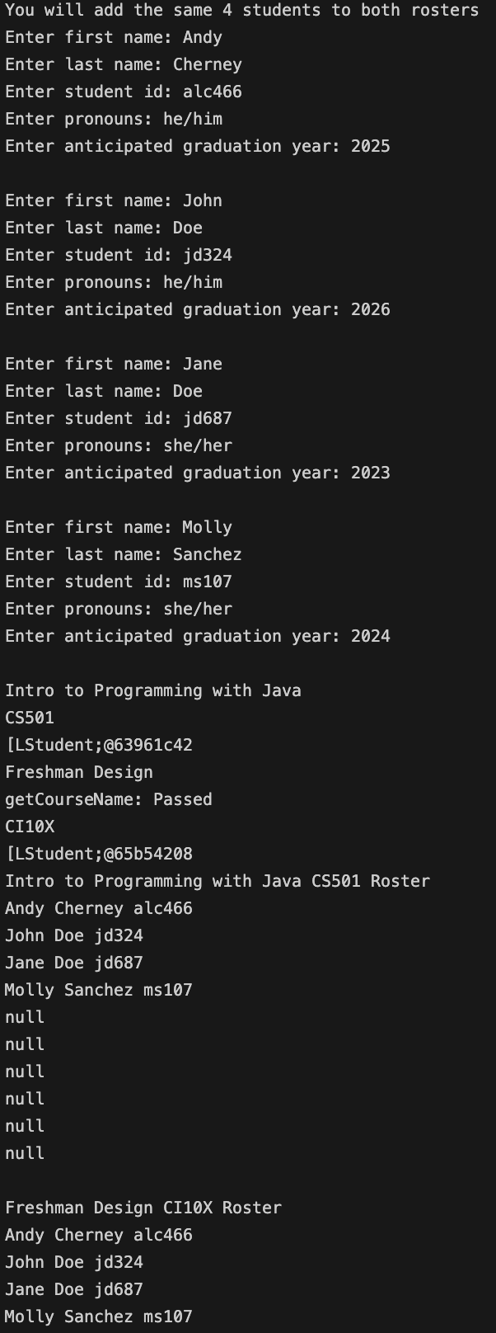

Reflect on your learning and your needs. After this class meeting, what topics do you feel like you learned and what topics do you feel like you need more information on to learn?

I would say I learned about arrays and their differences to ArrayLists. I learned about parallel arrays, 2d and higher dimensional arrays, methods with an unknown number of parameter, and also how to loop over the arrays.